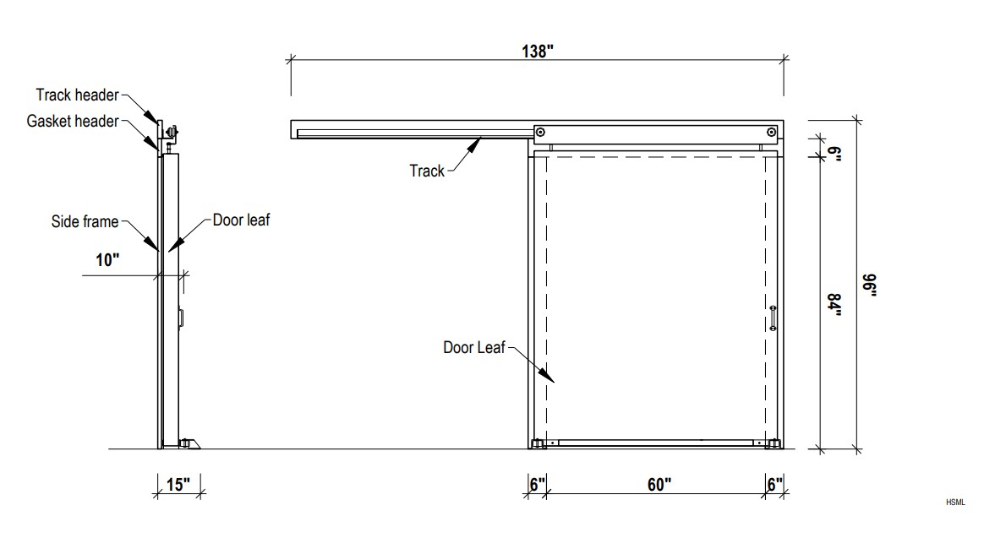

SLIDERS CAN BE MADE TO ANY SIZE, AND SPECIFICATION

DIVERISFIED PANEL SYSTEMS

